**Objective:-** JSP program to demonstrate jsp: forward action tag.

**Code :-**

**src/main/webapp/index.jsp**

<%@ page language="java" contentType="text/html; charset=UTF-8" pageEncoding="UTF-8"%>

<html>

<head>

<title>JSP Forward Example</title>

<link href="https://fonts.googleapis.com/css2?family=Poppins:wght@400;500;600&display=swap" rel="stylesheet">

<style>

/* Reset and general styling */

* {

margin: 0;

padding: 0;

box-sizing: border-box;

}

body {

font-family: 'Poppins', sans-serif;

background: linear-gradient(135deg, #74EBD5, #ACB6E5);

min-height: 100vh;

display: flex;

justify-content: center;

align-items: center;

}

.container {

background: #ffffff;

width: 90%;

max-width: 600px;

border-radius: 12px;

box-shadow: 0 10px 30px rgba(0, 0, 0, 0.2);

padding: 30px;

text-align: center;

transition: 0.3s ease;

}

.container:hover {

box-shadow: 0 15px 40px rgba(0, 0, 0, 0.3);

}

h2 {

font-size: 30px;

color: #333;

margin-bottom: 20px;

font-weight: 600;

}

p {

font-size: 16px;

color: #555;

margin-bottom: 20px;

}

input[type="submit"] {

background: #4CAF50;

color: white;

border: none;

padding: 12px 25px;

font-size: 18px;

font-weight: 500;

border-radius: 8px;

cursor: pointer;

transition: 0.3s;

font-family: 'Poppins', sans-serif;

}

input[type="submit"]:hover {

background: #45a049;

}

@media (max-width: 768px) {

.container {

width: 95%;

padding: 20px;

}

h2 {

font-size: 24px;

}

p, input[type="submit"] {

font-size: 14px;

}

}

</style>

</head>

<body>

<div class="container">

<h2>Welcome to JSP Forward Example</h2>

<p>Click the button to forward this request to another JSP page.</p>

<form action="first.jsp">

<input type="submit" value="Forward Now" />

</form>

</div>

</body>

</html>

**src/main/webapp/first.jsp**

<jsp:forward page="second.jsp">

<jsp:param name="firstName" value="Aryan"/>

<jsp:param name="lastName" value="Langhanoja"/>

</jsp:forward>

**src/main/webapp/second.jsp**

<%@ page language="java" contentType="text/html; charset=UTF-8" pageEncoding="UTF-8"%>

<%

String firstName = (String) request.getParameter("firstName");

String lastName = (String) request.getParameter("lastName");

%>

<!DOCTYPE html>

<html>

<head>

<title>Forwarded Page</title>

<link href="https://fonts.googleapis.com/css2?family=Poppins:wght@400;500;600&display=swap" rel="stylesheet">

<style>

/* Reset and base styling */

* {

margin: 0;

padding: 0;

box-sizing: border-box;

}

body {

font-family: 'Poppins', sans-serif;

background: linear-gradient(135deg, #74EBD5, #ACB6E5);

min-height: 100vh;

display: flex;

justify-content: center;

align-items: center;

}

.container {

background: #ffffff;

width: 90%;

max-width: 600px;

border-radius: 12px;

box-shadow: 0 10px 30px rgba(0, 0, 0, 0.2);

padding: 30px;

text-align: center;

transition: 0.3s ease;

}

.container:hover {

box-shadow: 0 15px 40px rgba(0, 0, 0, 0.3);

}

h2 {

font-size: 30px;

color: #333;

font-weight: 600;

}

@media (max-width: 768px) {

.container {

width: 95%;

padding: 20px;

}

h2 {

font-size: 24px;

}

}

</style>

</head>

<body>

<div class="container">

<h2>Hello, <%= firstName %> <%= lastName %>! You have been forwarded to this page.</h2>

</div>

</body>

</html>

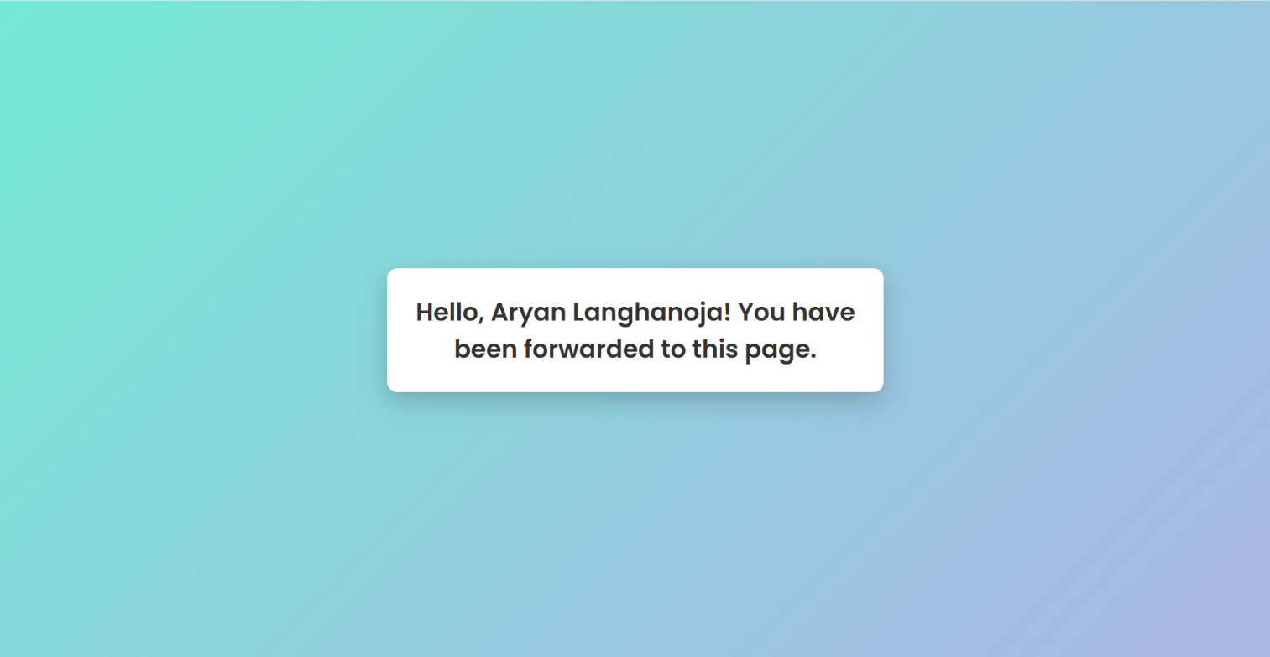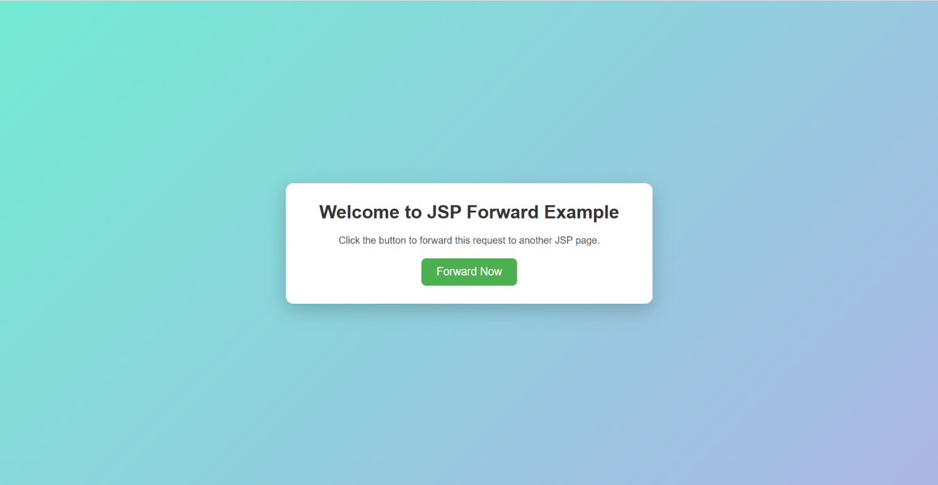**Output:-**